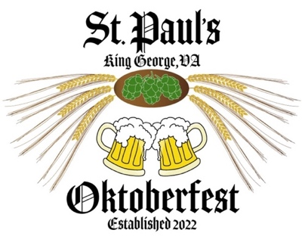
St. Paul’s Oktoberfest

Saturday, September 26, 2026 • 12-8 pm

FIFTH ANNUAL EVENT

St. Paul’s Episcopal Church will be hosting its fifth annual Oktoberfest, and we invite you to consider becoming a sponsor! Funds raised will support St. Paul’s mission to build community, its operations, and the caretaking of our historic property.

We offer six different levels of sponsorship, with benefits described below.

- St. Paul’s Signature Sponsor ($5,000)  - Reserved seating.  - Receive 100 tickets ($100 value) to purchase food and drinks at the event. | - Braumeister Sponsor ($2,500)  - Reserved seating.  - Receive 80 tickets ($80 value) to purchase food and drinks at the event.
- Gemeinschaft Sponsor ($1,000)  - Receive 60 tickets ($60 value) to purchase food and drinks at the event. | - Bavarian Sponsor ($500)  - Receive 40 tickets ($40 value) to purchase food and drinks at the event.
- Festwirt Sponsor ($250)  - Receive 20 tickets ($20 value) to purchase food and drinks at the event. | - Friends of Oktoberfest ($100)  - Reserved for individuals and families.

Consult with your tax advisor, but generally sponsorship events are tax deductible minus the value of goods received. Sponsors opting out of some or all tickets received can deduct up to the full sponsorship value.

There will be a sponsors’ welcome table at the event to check-in and pick up your tickets.

Commercial sponsors are invited to provide hand-out,
promotional materials that we will display.
Sponsors will be recognized as follows:
- Recognized on the St. Paul’s Oktoberfest website and Facebook page.
- Identified on Sponsors boards and banners at the event.
- Signature Sponsors will be recognized by the band and/or our Mistress of Ceremonies.

Two ways to pay, with our thanks!
- Please complete and mail the attached form with your check to St. Paul’s (address below); make check payable to St. Paul’s Episcopal Church, with Oktoberfest Sponsor in the memo field.
- Pay via credit card on our website, using the QR codes on the reverse of this sheet.

Please note: sponsorships are nonrefundable.
Sponsorship Levels
☐ St. Paul’s Signature Sponsor ($5,000)  Reserved seating.  Receive 100 tickets ($100 value) for food and drinks. | 
☐ Braumeister (“Master Brewer”) Sponsor ($2,500)  Reserved seating.  Receive 80 tickets ($80 value) for food and drinks. | 
☐ Gemeinschaft (“Community”) Sponsor ($1,000)  Receive 60 tickets ($60 value) for food and drinks. | 
☐ Bavarian Sponsor ($500)  Receive 40 tickets ($40 value) for food and drinks. | 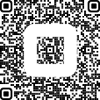
☐ Festwirt Sponsor ($250)  Receive 20 tickets ($20 value) for food and drinks. | 
☐ Friend of Oktoberfest ($100)  Reserved for individuals and families. | 